Announcements - Create an Announcement
Course > Announcements > + Announcement
•Use this to communicate important events for your course

Assignments - Create an Assignment
Course > Assignments > + Assignment OR to Add Assignment from the Course Calendar> Calendar > Click on date > Assignment tab > Submit or go to More Options to add details
•Create assignments such as papers, projects, etc.
•Create Assignment Groups that can be weighted
•Download Assignment submissions from Grades and use Speedgrader

Calendar - Create an Event
Calendar > Click on Date > Event tab > Submit
•More options to open Rich Content Editor and Content Pane
•Drag & drop events or assignments to make changes across weeks or months
•View up to 10 classes at once with color-coded global calendar view and toggle

Chat - Join Chat
Course > Chat
Global Navigation > Courses & Groups > Group > Chat
•Chat in real time at the same URL (Chat logs not saved)
•Broadcast via webcam or computer audio

Collaborations - Create New Collaboration
Course > Collaborations > add people > Start Collaborating
•Invite any subset of the People enrolled in a course or group

Course Navigation - Customize Course Navigation
Course > Settings > Navigation > Drag above/below line to show/hide
•Course Navigation is a customizable list of links that helps you GO where you need to inside your course. You can turn on and off what you want your students to see.

Course Statistics - View Course Statistics
Course > Settings > Course Statistics
•Total number of Assignment types
•Recent student visits
•Graph of page views over time

Discussions - Create a New Discussion
Course > Discussions > + Discussion
•View Discussion Topics and Announcements or just Discussion Topics
•Use Rich Content Editor and Content Pane to edit Topic
•Attach Files to Discussions
•Discussion options: delay posting, reply visibility
•Turn a Discussion into a graded Assignment

Conferences - Create New Conference
Course > Conferences > Make a New Conference
Group > Conferences > Make a New Conference
•Conferences can be long-running or limited to x number of minutes
•Describe purpose of Conference in the description field
•Invite any subset of the People enrolled in a course or group

Conversations - Create New Conversation
Inbox > to open To: field > Name, Message, Send
•Messages can be sent to any of your classes, sections, groups
•Users can color code, archive, and unsubscribe from a Conversation
•Message threads include comments from past Assignments

Course Home Page - Change Home Page Layout
Course > Home > Change Home Page Layout
•Course Activity Stream (Default), Design Custom Page, Modules Page, Assignments, Syllabus

Course Import/Export Tool - Import/Export Course Content
Course > Settings > Copy this Course
Course > Settings > Import Content into this Course
Course > Settings > Export this Course
•Exported course packages can be shared via email

ePortfolios - Create a New ePortfolio
Profile > ePortfolios > Create an ePortfolio
•Organize ePortfolio into Sections with Pages
•Widgets: Rich Content Editor, HTML Embed, Course Submissions, Images/Files

•Enable comments; make comments public; make ePortfolio public
•Download ePortfolio as .zip files
•ePortfolios belong to a user not a course

Course Files - Access Course Files
Course > Files
•File hierarchy on the left / File preview pane on the right
•Upload single files or .zip files
•Sort files into folders (Mouse over file icon to move files from right to left)
•Preview files by clicking on the file title
•Three levels of security: public (default), locked until linked, always locked
•Download single files .zip files

Grades - Edit Grades
Course > Grades > Click on Arrow for Options
•Grading history is always saved, can revert to past grades
•Leave media comments to provide assessment feedback
•Download CSV export of gradebook, edit, and re-upload
•Include or Ignore ungraded Assignments to calculate Total Grade
•Students see a table of all course Assignments and can figure out hypothetical grades

Log in to https://fairburyjeffs.instructure.com
Username: first letter of your first name and last name ex: kdux
Password: fairbury (Change this right away!)
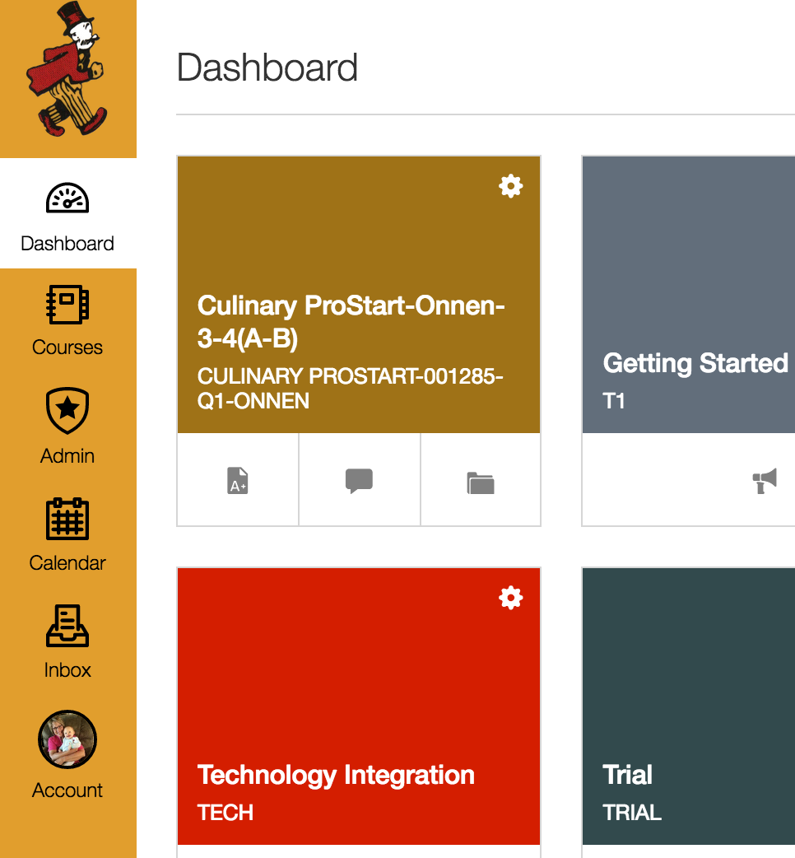
Click Account.

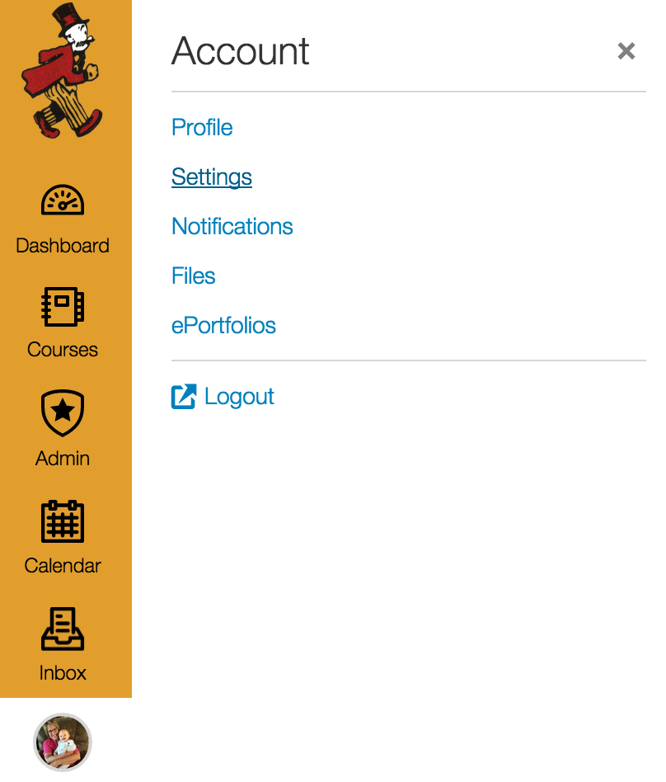
Click Settings.

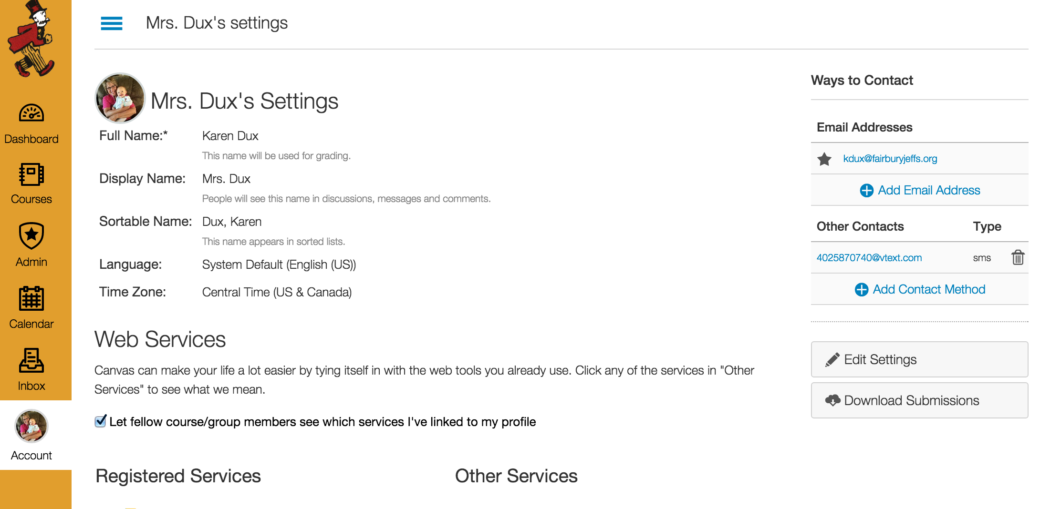
Click Edit Settings.

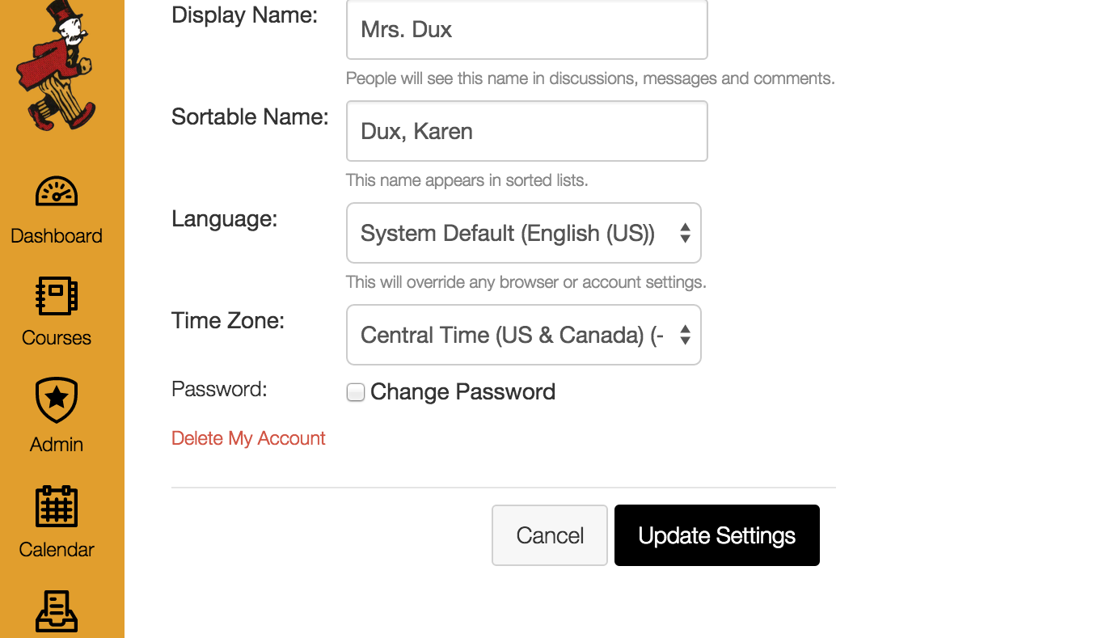
Click Change Password.
Change your password to your school password.

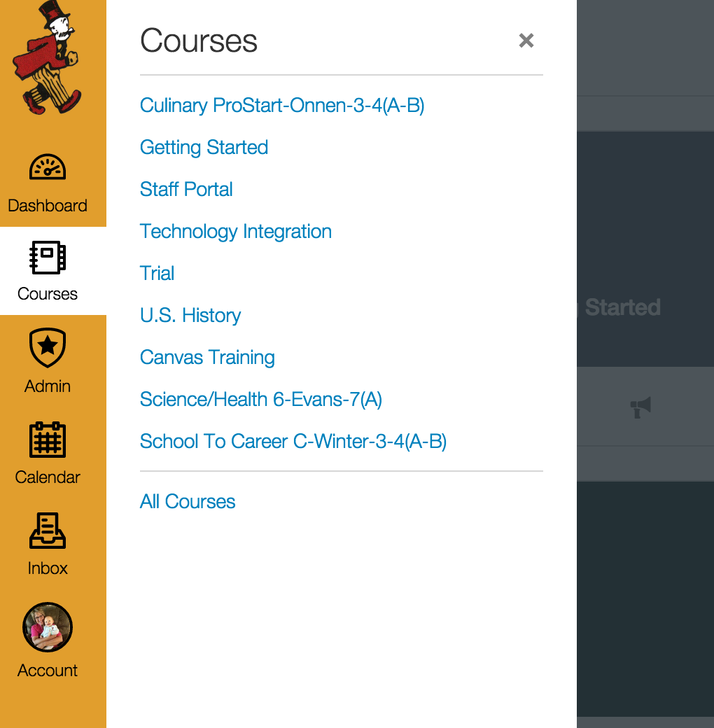
Click on Courses and All Courses.

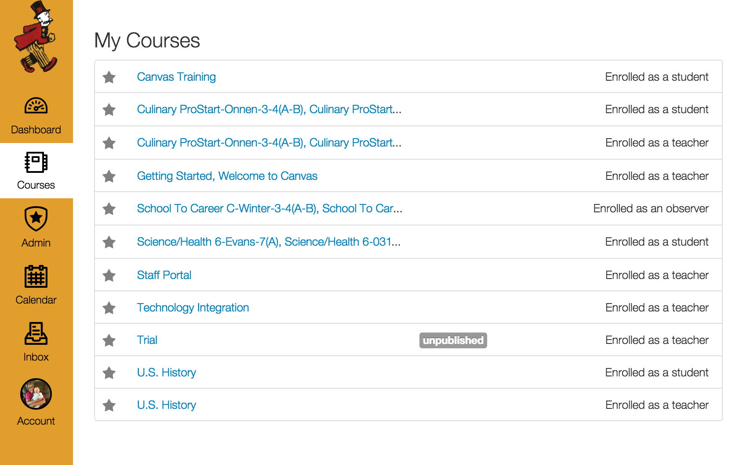
Click in each star of the courses you are currently teaching. Make sure the star is colored. They will be the courses that appear on your dashboard.

Click on Dashboard. All of the courses that you starred will show up.

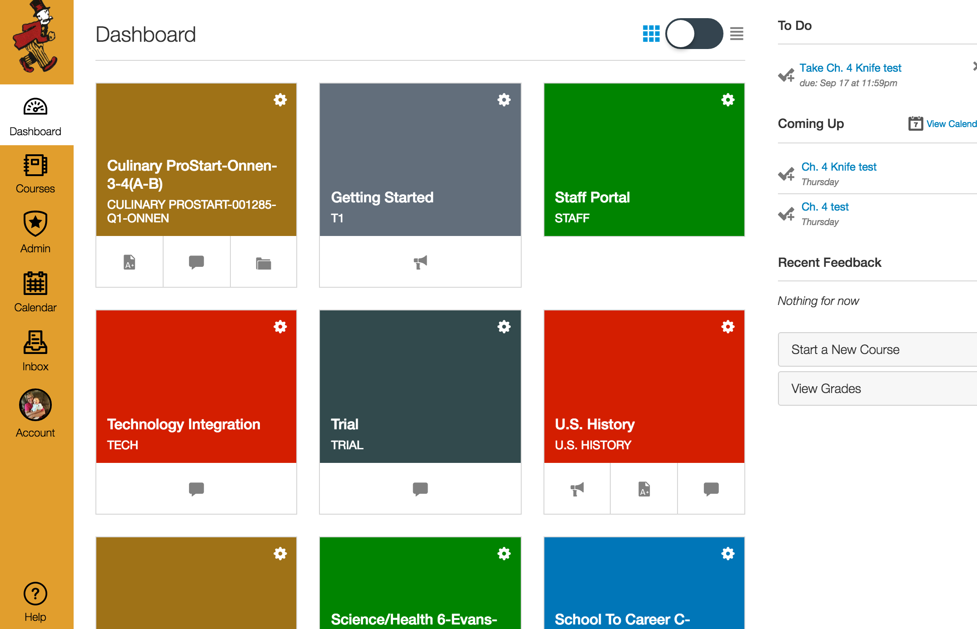
Select the course you want to edit.

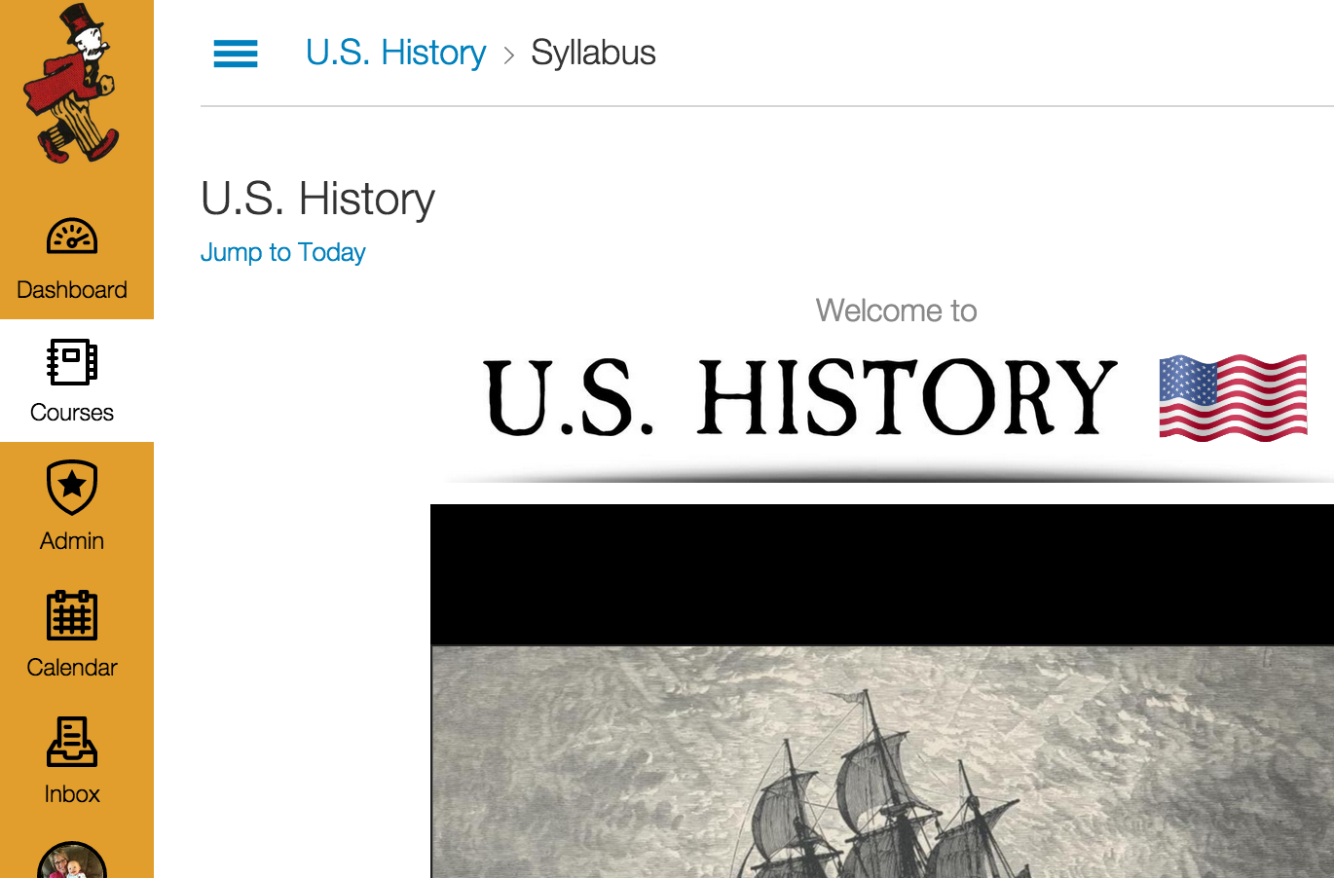
The menu on the very left side is your Canvas menu for all courses and settings. Click on the three small vertical lines to access your course menu.

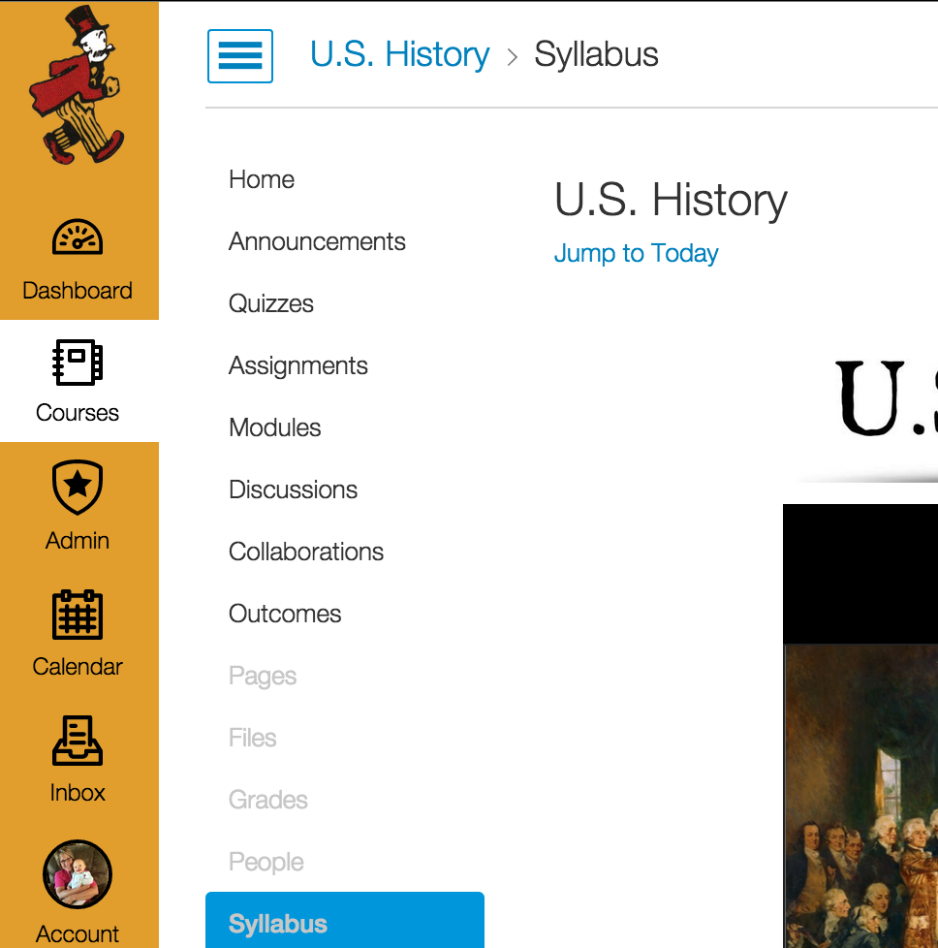
Some of the items will be gray because you have not created content yet, but after you create something like a quiz, they will appear dark. You can customize which menu items your students will see by going to the course settings in the course menu.

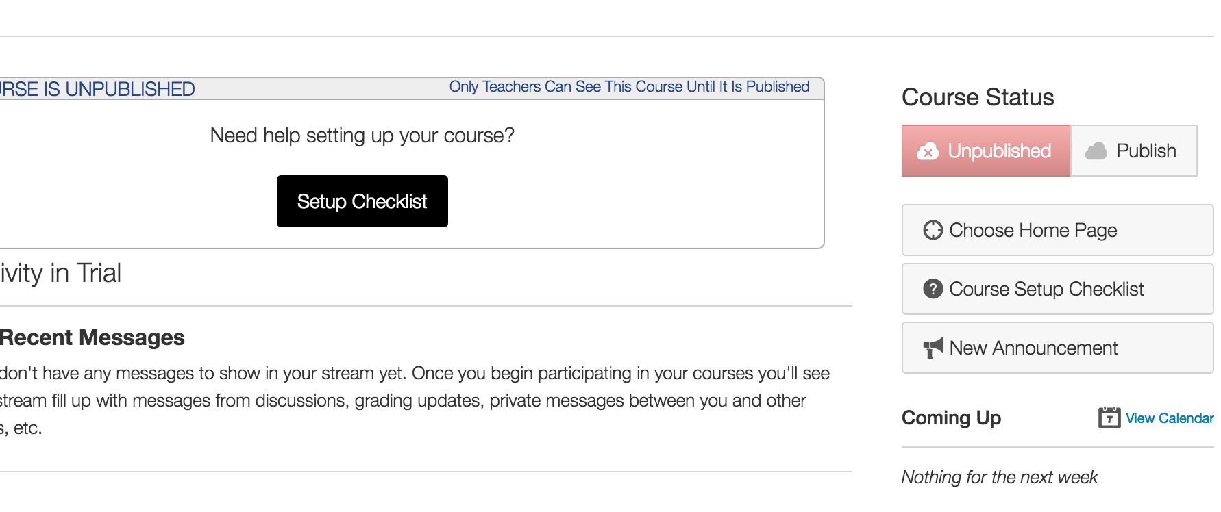
Choose your Home Page. You can choose a syllabus, modules, stream, or create a new page and link off of that to your modules and syllabus. It is customizable to your teaching style.

Now you can follow the cheat sheet! If in doubt about something, Google it. There are many online resources to help you.

